Tittle: Speed estimation and angular position for the activation of tasks by events in a scheduler

History
Issue status  (Index) | Maturity/Date  (draft/invalid/valid)  (dd-mmm-yyyy) | Author  Department | Check/Release  Department | Description
1.0 | Draft  03-09-2015 | Erick Salinas  Ricardo Guerra | AEP | Creation of the document.
1.1 | Draft  07-09-2015 | Erick Salinas  Ricardo Guerra | AEP | Diagrams addition
2.0 | 09-09-2015 | Erick Salinas  Ricardo Guerra | AEP | Functions Overview

Table of Contents
1 Purpose 4
2 Definitions and abbreviations 4
3 Realization constraints and targets 4
4 Conceptual design 5
4.1 Uses Diagram 5
5 SW Component internal breakdown 6
5.1 Architecture Design 6
5.2 Class Diagram 7
5.3 Sequence Diagram 8
5.4 Functions Overview 10
5.4.1 Function void PWMControl(T_ULONG SpeedSgnl) 10

5.4.1 Function void CurrentMeasure(T_ULONG lul_CurrentSgnl) 10

5.4.1 Function T_ULONG Read_Encoder(void) 10

5.4.1 Function void set_Duty_Cycle(vuint16_t Duty) 10

5.4.1 Function T_ULONG SpeedSampler(void) 10

5.4.1 Function void SpeedMeasure(T_ULONG lul_SpeedSamplesTable[]) 10

6 Comments and Disclaimer 11

Purpose
Understanding the behavior of a scheduler (replacing an operating system) oriented control system of an internal combustion engine, in turn control the speed and position of a DC motor (replacing the internal combustion engine) in an automotive system where the current speed and the failures are reported through a network of CAN in synchronization with a defined position of the motor.

Definitions and abbreviations
Definitions
DC Direct Current
PWM Pulse Width Modulation
ADC Analog to Digital Converter
CAN Controller Area Network
EMIOS Enhanced Modular Input Output System
PIT Periodic Interruption Timer
GPIO General Purpose Input Output
PLL Phase Lock Loop
MCU Microcontroller
MAL Microcontroller Abstraction Layer
HAL Hardware Abstraction Layer

References
N° | Document name | Reference
1 | ES_Requirements | ⁽¹⁾
2 | Traceability matrix | ⁽²⁾

Realization constraints and targets
- The engine control module will be connected to a CAN network where a master module will be commanding data through defined messages.
- It will have a DC motor which speed will be controlled depending on the received commands.
- For this practice the next modules are already integrated in a base project: CAN driver, PWM Driver and Scheduler.
- The CAN driver will allow to the user set the different messages to be published in the bus according to the described requirements.
- The PWM driver will allow to the user control the frequency and the duty cycle that will control the motor’s speed through the H Bridge.
- The Scheduler will allow to the user set different tasks that could be periodic or activated by events.
- The set tasks will be those tasks synchronized with angular events from the DC motor.

Conceptual design

Uses Diagram

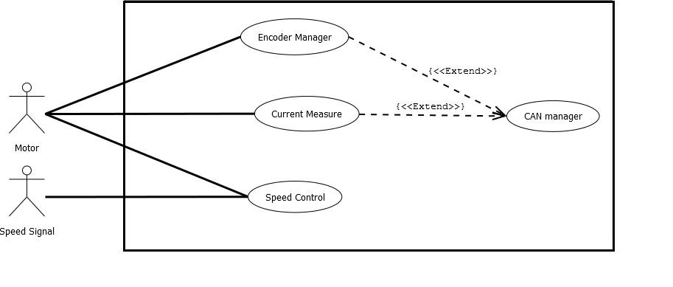

Figure 1. Case uses Diagram

Motor: DC motor that includes a decoder to measure the angular movement.
Speed Signal: Signal from a potentiometer that simulate the speed change on the motor.
Encoder Manager: Receive the data from the encoder and counts how many grades the motor moved
Current Measure: It checks the simulated current signal from a potentiometer and calculate the current for the CAN message.
Speed Control: Receive the speed signal and translate into the PWM signal to control the speed of the motor.
Can Manager: This module is in charge of use the recollected data from the lower layer and set the CAN messages that are going to be sent to the bus CAN.

SW Component internal breakdown

Architecture Design

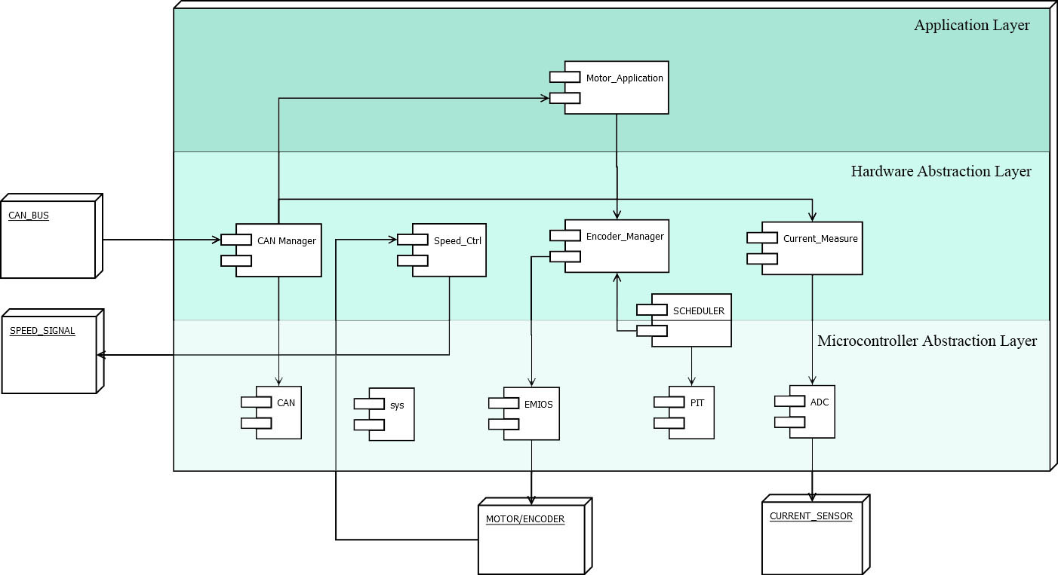

Figure 2. Components Diagram

SYS: Configures the running mode of the MCU and set the multiplication for the external clock.
EMIOS: Configures the modular outputs to be used for the PWM signal that control the motor speed.
ADC: Configures the both ADC module in the board to be used to receive the speed and current signal through a potentiometer.
PIT: Control the timer interruption configuration as well as its start and stop.
CAN: Configures the CAN module of the MCU. Set the Tx and Rx ports and initialize the CAN communication.
SCHEDULER: The system is mounted on a rate monotonic, no preemptive scheduler designed to work with a 500ms OStick. All the documentation about the Scheduler are described in the Scheduler Specification Document.
CAN Manager: It sets the CAN messages to be sent.
Speed_ctrl: Driver that configure the duty cycle based on the read from the ADC that simulate de Speed signal.
Encoder_Manager: This driver receives the data from the encoder and counts how many grades the motor moved.
Current_Measure: Module that checks the simulated current signal from a potentiometer and calculate the current for the CAN message.
CAN_Manager: This module is in charge of use the recollected data from the lower layer and set the CAN messages that are going to be sent to the bus CAN.
Motor_Application:

Class Diagram

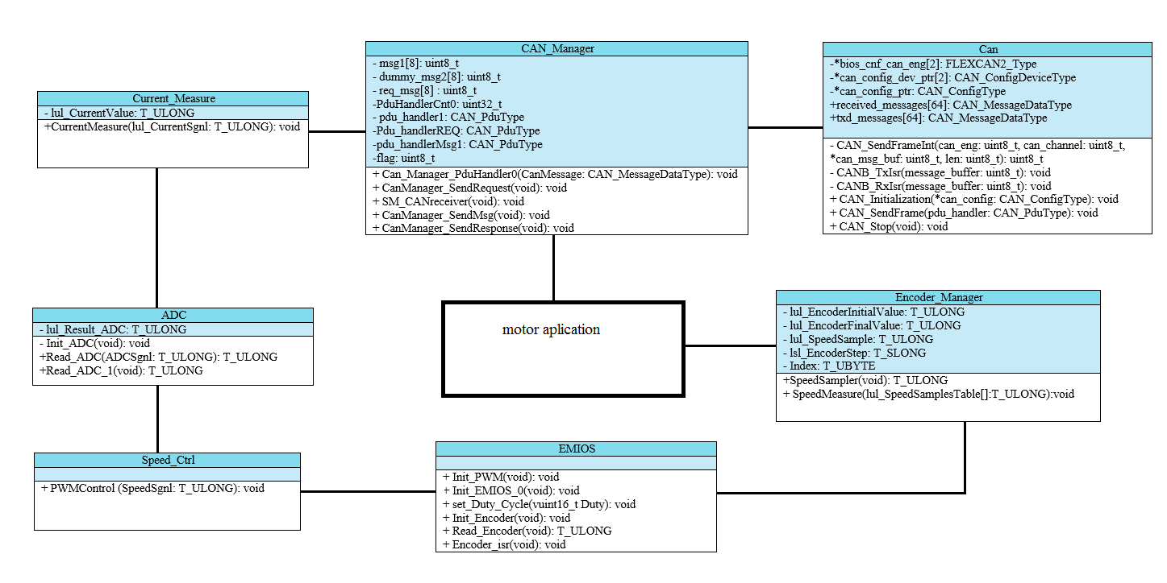

Figure 3. Class Diagram

Description of the module functions and the way they interact with each other. It is shown how the modules follow the architecture design. The direction of the arrows indicate how is the transference of information. Every module contains defines and functions necessary to the proper function of the specific task of the module, taking care of the portability of them.

Sequence Diagram

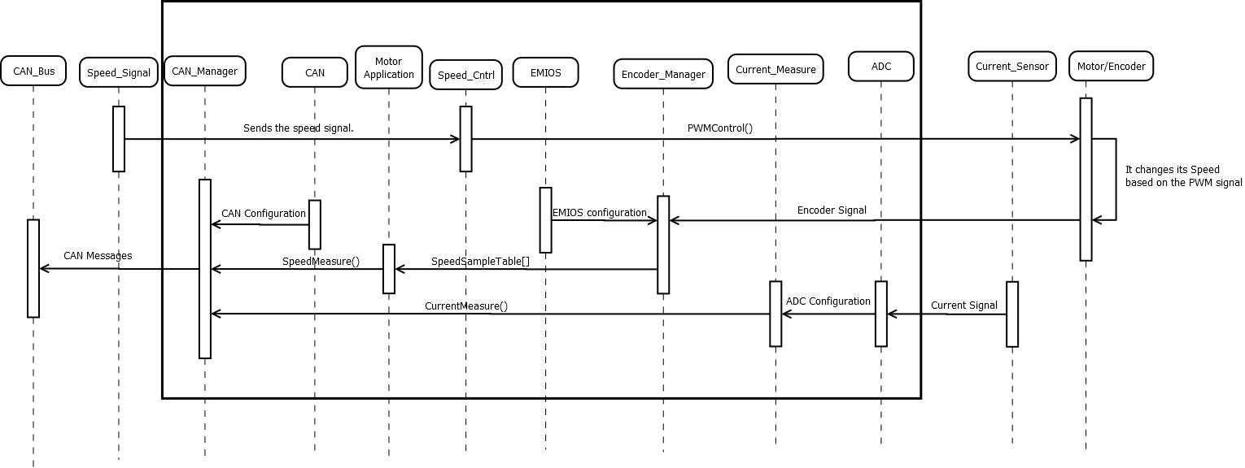

Figure 4. Sequence Diagram

PWMControl (): Translate the speed signal into the PWM signal.
SpeedSampleTable (): It fills an array with ten samples from the motor speed.
Currentmeasure (): It calculates the current using the data received from the ADC assigned to the current sensor.
SpeedMeasure (): It calculates the speed and RPM’s using the data saved in the SpeedSampleTable.
Encoder Signal: Signal that comes from the encoder used to calculate the current motor angle and the angular tasks.
Current Signal: This signal comes from the potentiometer, and is used to simulate the current.
EMIOS configuration: Function that Initializes and configures the EMIOS module.
ADC configuration: Function that Initializes and configures the ADC module.
CAN configuration: Function that Initializes and configures the CAN module.
CAN Messages: It sets the CAN messages to be send to the CAN bus, using all the data from the previous measurements

Functions Overview

Function void PWMControl(T_ULONG SpeedSgnl)
Description | Receives the speed signal and set the PWM signal to sends it to the motor
Parameter | T_ULONG SpeedSgnl
Return Value | void
Precondition | The EMIOS must be initialized and configured to use the PWM function
Post condition | Set the PWM value

Function void CurrentMeasure(T_ULONG lul_CurrentSgnl)
Description | Receives the current signal from the ADC and calculate the current
Parameter | T_ULONG lul_CurrentSgnl
Return Value | Void
Precondition | Should have assigned one pin as analogue input
Post condition | Deliver the current value ready to be send in a message

Function T_ULONG Read_Encoder(void)
Description | Initialize EMIOS to work counting pulses from encoder.
Parameter | void
Return Value | T_ULONG
Precondition | The channel must be set to count with an external event.
Post condition | Deliver the count for the angular tasks

Function void set_Duty_Cycle(vuint16_t Duty)
Description | Changes duty cycle of PWM.
Parameter | vuint16_t Duty
Return Value | Void
Precondition | The channel must be set like Output Pulse Width Modulation
Post condition

Dynamic Behavior

Function T_ULONG SpeedSampler(void)
Description | Changes duty cycle of PWM.
Parameter | void
Return Value | T_ULONG
Precondition | The angular task for 20 degrees must be created
Post condition | The speed value must be send it the function in charge of filling the table with the samples

Dynamic Behavior
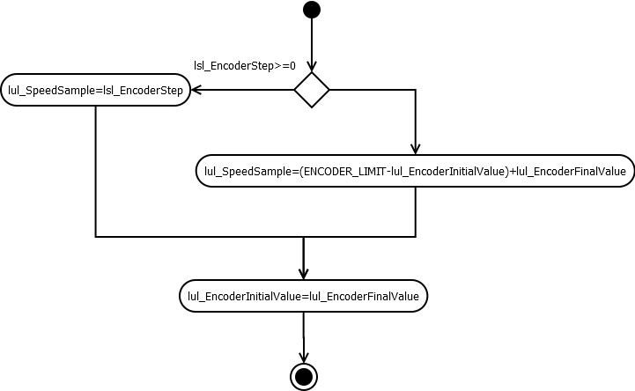

Function void SpeedMeasure(T_ULONG lul_SpeedSamplesTable[])
Description | Changes duty cycle of PWM.
Parameter | T_ULONG lul_SpeedSamplesTable[]
Return Value | void
Precondition | The angular task for 20 degrees must be created
Post condition | The speed value must be send it the function in charge of filling the table with the samples

Dynamic Behavior

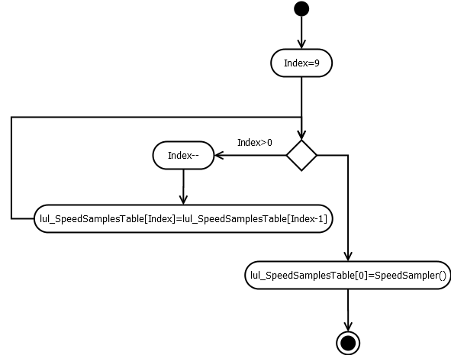

Comments and Disclaimer

